Complete Draft
Abstract: Based on anecdotal claims, violins that are more highly priced are often preferred over those that are not, due to their supposedly higher sound quality. While this may be true when comparing instruments in the $100 range to $10,000 range, this study will explore whether or not high-priced violins are objectively better than others in a similar price range. Violins that are worth anywhere from $100 to $100,000+ will be the center of this study. Instruments in the upper echelon of the price range will be compared against each other to determine if there is any objective difference between the sound of the higher-level instruments. Digital signal processing will be applied to determine objective differences in sound quality. Sound samples that are recorded with special equipment will be digitally processed and examined in the frequency domain; analysis techniques in the frequency domain used in this study include the Fast Fourier Transform (FFT) and the Short-Term Fourier Transform (STFT). Spectrograms that can visualize the frequency domain of the instruments will be created, from which the intensities of different harmonics can be observed. Having applied this frequency domain analysis, the different harmonic intensities can be cross correlated against the different qualities of wood and methods of construction of the instruments. The result of this study will be a catalogue documenting different methods of construction and quality of material and how they impact harmonic intensities.

Review of Literature
Signal processing as a field of Computer Engineering is something that can be applied to many different disciplines. From recovering archaeological data to analyzing chess matches, the applications of signal processing are virtually boundless. These bounds also extend to encompass music, as all sound can be represented as a time-varying signal in the form of a pressure wave or voltage. The techniques of signal processing can then be applied to these signals, and information that may be imperceptible with the human ear can be extracted. Some signal processing techniques that can specifically be applied to music will be explored in this review.
The study of literature started broad, looking at recent developments in signal processing as it pertains to music. Machine learning is a big topic in signal processing lately; a paper by Therrick-Ari Anderson at Lincoln University studied musical instrument identification by using neural networks. The paper used libraries in a tool called MATLAB that took care of most of the signal processing [1]; the underlying algorithms under the libraries were also briefly introduced, mainly the Fast Fourier Transform (FFT).
In search of more recent work, we found research conducted by Atahan et. al. at Yildiz Technical University in Istanbul, Turkey. This paper focused on music genre identification using machine learning techniques such as autoencoders [2]. Again, we see the prevalence of machine learning in recent research. This study applied wavelet transforms to extract features from audio; the extracted features were then fed into the autoencoder algorithm developed by the team [2].
A common theme of time-to-frequency domain transforms appeared in the literature; both the FFT and wavelet transform take time-domain data and transform it into frequency domain information. This prompted further investigation into these algorithms. Research conducted by the Department of Applied Electronics and Instrumentation at the Government Engineering College in Kozhikode, Kerala investigated using Spectrograms for Genre Classification [3]. A spectrogram is an application of the FFT that is very useful in analyzing sound data; it breaks a sound file into small pieces and applies the FFT to those small pieces. The study concluded that spectrograms were an accurate and reliable transformation to analyze music in the frequency domain [3].
Lastly, a more refined search was performed to locate literature that is directly pertinent to the subject matter of this study. A study conducted at the Department of Computer Science and Engineering at National Cheng-Kung University explored quantitative evaluation of violin performance by means of signal processing [4]. This study looked at both time and frequency domain data, making use of spectrograms in close relation to the goal of this project. The evaluation criteria set by the study, such as pitch variation and characteristics of vibrato [4], may be applied to our project to determine quality of instruments as opposed to quality of performance.

Signal processing is a very wide field, with applications ranging from digital communication and data transfer to fields like power generation and weather forecasting. In the real world, almost any phenomena can be viewed as a signal, which may vary both in time and frequency. When looking at music, signal processing is something that comes very naturally. In its simplest form, music can be seen as sound, which is a time-varying pressure wave measured at the ear drum. The intensity of this pressure wave is how loud the sound is, and the frequency of oscillation of this pressure wave is the pitch of the sound wave. This realization allows us to applying signal processing techniques to analyze music.
Many techniques in signal processing involve viewing time-varying signals in the frequency domain. Earlier, we arrived at the conclusion that sound can be viewed as a pressure wave that varies with respect to time. This view of sound tells us a lot of information, like how loud the sound is at any given point, how long our sound lasts in the time domain, and other similar features. While this is a helpful representation, it does not tell us what frequencies comprise our sound wave. Signal processing allows us to solve this problem, by giving us a tool known as the Fourier Transform, which takes a signal from the time domain to a signal in the frequency domain. The frequency domain can tell us what frequencies make up our sound, along with the intensities of each frequency.
Before we discuss the Fourier Transform and its many variants, it is important to discuss one factor that can hold the technique back if not applied correctly: sampling. Music exists in the continuous world, where our ears can perceive changes in sound continuously. To apply signal processing, our music must be sampled and digitized—this induces error in multiple ways. First, a digital system cannot sample continuously, meaning there is loss of information to some degree. For example, consider a digital system that samples at a frequency of 200 Hz, and a violinist playing his open A string, which rings at 440 Hz. Since the digital system samples at a frequency lower than the fundamental of the note, it will not accurately capture the 440 Hz waveform, resulting in aliasing. Sample theory tells us that to accurately capture a signal, it must be sampled at twice the frequency of its highest frequency component. Therefore, most music is sampled at 44.1 kHz; humans cannot hear frequencies larger than 20 kHz, so the sampling frequency must be at least 40 kHz. The extra 4.1 kHz is an engineering margin to account for error. This is all relevant information for this project, as the goal is to analyze high frequency content of violins, which would require a high sampling rate. It is also relevant to the algorithms we will be working with, as sampling can impact the performance of these techniques.
Considering sample theory, the simplest form of the Fourier Transform (FT) is the Discrete-Time Fourier Transform (DTFT). This is a rudimentary form of the FT, which can take in an infinite-length sampled input and produce a frequency spectrum that is continuous in both frequency and amplitude. The algorithm does this by multiplying the signal by a sinewave of all possible frequencies and storing the amplitude of the output. It is important to note that this is partially a theoretical construct, as no computer could store a continuous spectrum.
To account for this, the Discrete Fourier Transform (DFT) is introduced, which is a sampled version of the DTFT. While the notation may be confusing here, it is important to realize that the DTFT and the DFT are two different but related things. The algorithm that implements the DFT, known as the Fast Fourier Transform (FFT), is the actual code that executes the calculations. While an algorithm for DTFT can be written, it is too computationally complex and slow to be used practically, so the FFT is used, which is an application of the DFT, which is an application of the DTFT. FFT is a couple layers removed, which is where we start to see some of its error. Because it’s a sampled version of another system, the frequency resolution is discrete. This may be a problem for us, as we need to view very small changes in very high frequencies. One way of getting around this would be to increase the sample rate significantly. If we do this, the algorithm is strong in the frequency domain; we would be able to accurately tell what frequencies occur and their strengths. The biggest drawback to this algorithm is the time-domain resolution. The FFT has no time domain resolution at all. While we may know what the frequencies are, we do not know at all when they occur. This may not be a problem for recordings that have single notes, but for anything more complex, the FFT fails.
This drawback leads us to the Wavelet Transform (WT), which is an algorithm like the Fourier Transform (FT) in its theoretical construction. Instead of multiplying the signal by a sinewave, the signal is multiplied by a waveform known as a wavelet. Sparing some technical details, using wavelets gives us a good time domain resolution at the expense of some frequency domain resolution. With this tool, we would know what frequencies occur when, and with what the intensities are. This is a good candidate option, but we sacrifice some of our frequency domain resolution when we use this.
The middle ground between the FFT and WT for our application is the Short-Term Fourier Transform (STFT), often known as a spectrogram. This algorithm functions by taking the full time-domain signal and slicing it into a set of smaller time domain signals. Then, the FFT is applied to each of the smaller time domain signals, producing a set of small frequency domain signals. The frequency domain signals are then all stitched together to produce a spectrogram, which tells us how frequency content varies with respect to time. This is the ideal algorithm for this project, as it gives us as much control as we want over time-domain resolution, and theoretically infinite precision in the frequency domain.

Short Term Fourier Transform
After exploring a few different algorithms and techniques in the previous section, we have settled on using the Short-Term Fourier Transform (STFT). This algorithm takes a sound file and splits it up into smaller sound files, often into time steps of one to two milliseconds. Recall from our discussion of sampling that audio is typically sampled at around 44.1 kHz; this means that a one millisecond audio clip will have 44 samples. A Fast Fourier Transform (FFT) algorithm is then applied to these smaller sound files; each FFT is combined into a plot known as a spectrogram. A plot of a spectrogram can be seen in Figure 1.
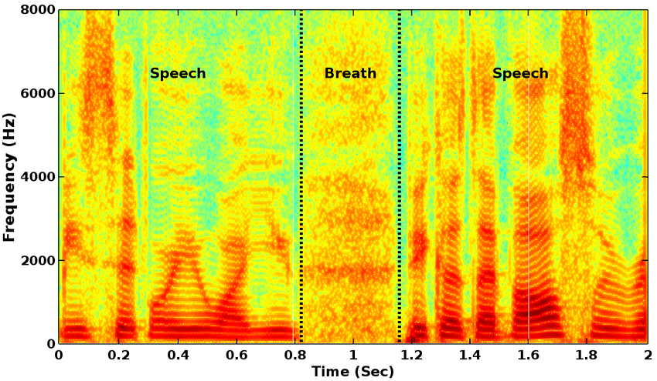
Figure 1: Spectrogram Plot
The color of the plot indicates the intensity of the frequency. For this plot, darker colors indicate a larger presence of the frequency, while lighter colors indicate a smaller presence. This plot can also be viewed as a three-dimensional construct, with peaks in the Z-axis representing intensity of sound. This can be seen in Figure 2.
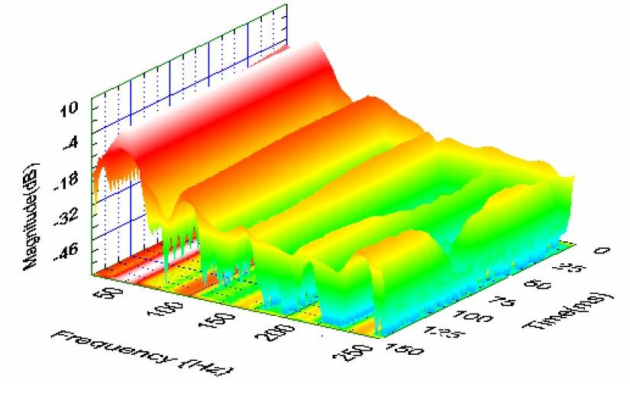
Figure 2: 3D Spectrogram Plot
These representations offer a good intuition of how the spectrogram works; specifically, it shows how much control we have over both frequency resolution and time resolution. Applying this to a sound file of a musical piece, we will know what frequencies occur with what intensity, and when they occur. Both two dimensional and three dimensional plot will be generated for different qualities of violins; from this, we will be able to discern patterns in the upper harmonics.

Initial Data Collection and Processing
The initial batch of instruments under study comprises of two instruments in the low-price range, and two instruments in the middle price range. The two low price range instruments are Kutz 100 violins, valued at $300.00; the two middle price range instruments are a John Cheng and Kono, both valued at around $3,000.00. It is important to note that the middle range instruments are about 10 times as expensive as the low range instruments; one focus of this project will be to determine if the more expensive instruments are truly better by a factor of 10.
For each instrument, a recording was taken of the open strings, a G major scale bowed, the harmonics on each open string, the G string plucked, and a G major scale plucked. This resulted in a total of 12 recordings for every instrument, and 48 recordings in total for this first batch of instruments.
For this project, the entire data collection process had to be done in a very controlled environment. The recordings for all of the violins were done in the same session and same room, using the same bow and same player. This methodology ensured that the unit under test was the violin and helped reduce variations in the data. The data was collected using the Zoom H1N recorder and sampled at 96 kHz. This specific recorder and sampling rate are important to the project, and steps will be taken in the data processing to preserve the sample rate.
MATLAB is a data processing language that is often used at engineering firms for data science and signal processing tasks. It is designed to be used to deal with very large amounts of data efficiently, both in terms of developing the software and using computational resources. The language functions through scripts, which are written to perform small dedicated tasks. Multiple scripts can be combined for more complex operations. In this project, MATLAB will be used for all stages of data processing.
Recalling our discussion about sample theory, the sampling rate is one of the defining qualities of a signal, and drastically impact the accuracy and range of our frequency domain analyses. It is important that we preserve the sample rate through the preprocessing stages. Each recording was taken with information about the recording spoken at the beginning (e.g. “Kutz 100 #1 Open G”), followed by the open G being played in this case. This information was not necessary for the data processing, and needed to be edited out.
Using audio processing software like Audacity was not effective for this, as it threw samples out of the data when exporting the edited audio, effectively reducing the sample rate. To get around this, a small MATLAB script was written to trim the data by hand. While this was more tedious and time consuming, the sampling rate of the data was not affected by the trimming process, resulting in no loss of essential data.
After preprocessing the data, I began my analysis by looking at the open string recordings and writing a script that can process and extract information from them. The first thing I looked at was the Fast Fourier Transform (FFT) of the open string recordings. Recall, the FFT is an implementation of the Fourier Transform that can perform quickly on large data sets, and gives good frequency resolution but poor time resolution. Since the pitch is not changing significantly with respect to time on the open string recordings, the FFT is a good algorithm to use here.
The FFT’s frequency resolution can be calculated by dividing the sampling frequency of our signal by the length of the signal in samples. For a 1 second recording sampled at 96 kHz, the frequency spacing would be 1 Hz, as 96,000 samples would be recorded in the one second time period by definition. Since our open string recordings are about 15-20 seconds each, the frequency resolution is very good for the open string recordings. The FFT of the open string recording of one of the Kutz 100 violins can be seen in Figure 1.
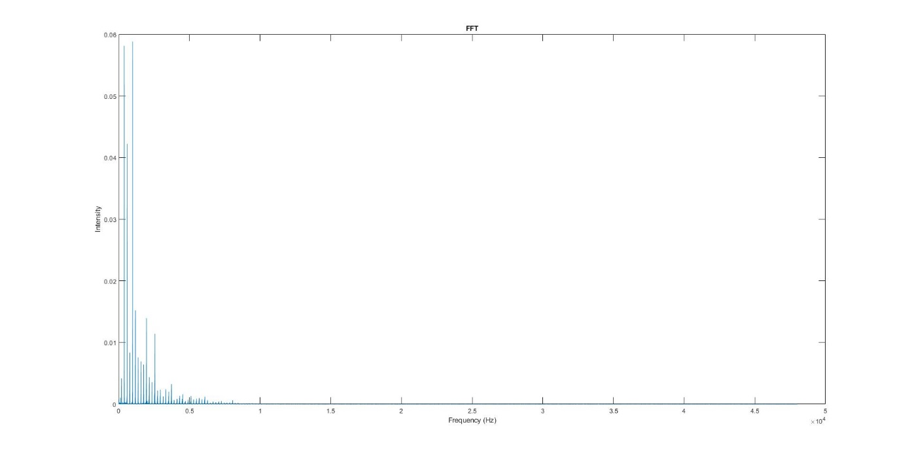
Figure 1: Kutz 100 Open G FFT
Note that the FFT will have a bandwidth of 48 kHz, meaning it is able to detect frequencies of up to 48 kHz. Most of the activity for all the open strings looks like this—the peaks are the harmonics of the fundamental. In this case, the fundamental frequency is the 196 Hz peak shown at the very left of the plot. While it may seem like the majority of the plot is zero or very close to it, zooming in and analyzing further shows that this is not the case. Due to the extreme differences in activity between the upper and lower frequency ranges, the two will have to be analyzed in different ways. Figure 2 shows a more enhanced version of the lower frequency range.
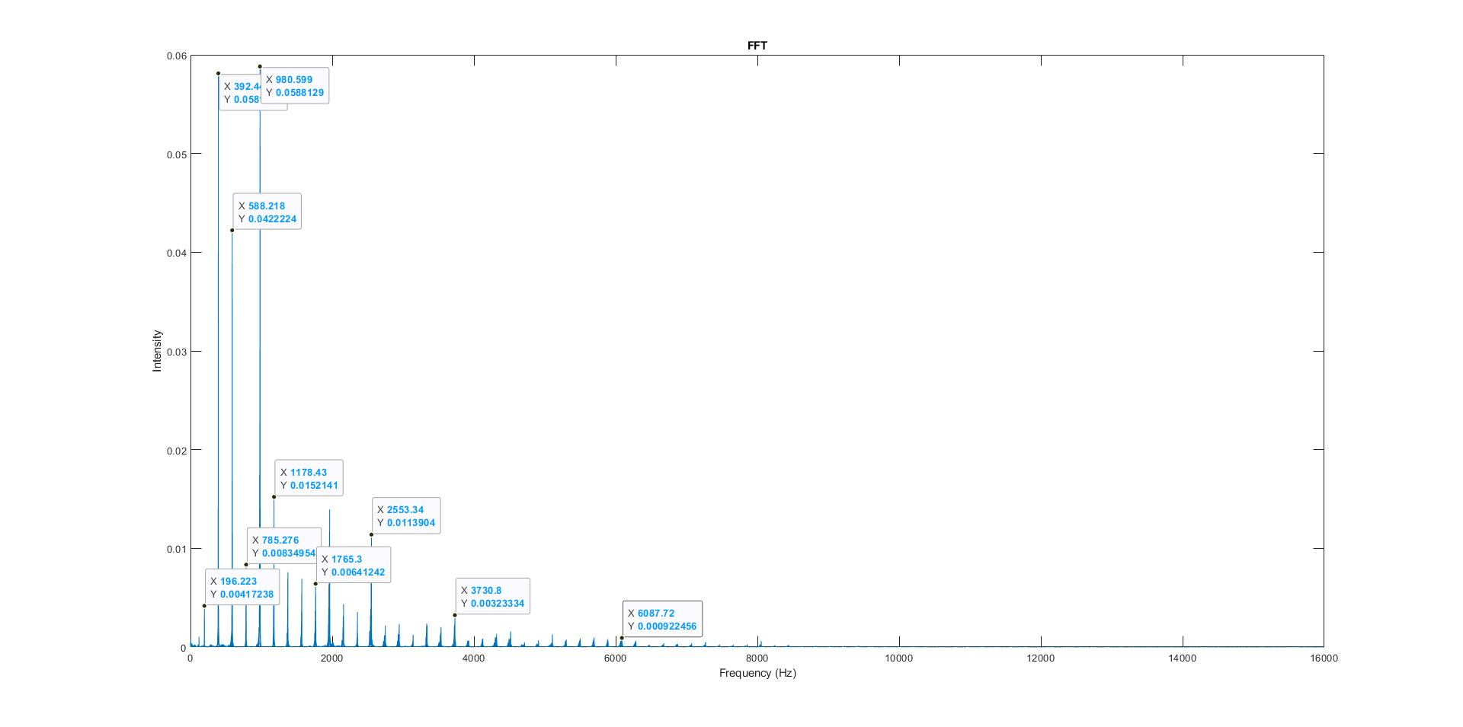
Figure 2: Kutz 100 Lower Frequency Range
Note that the peak of the fundamental on this instrument is very weak; in fact, this analysis tells us that the second, third, and fourth harmonics of the open G on the Kutz are at least 10 times stronger than the fundamental. Also note that the peaks on the harmonics of the lower frequency follow an approximately exponential trend, decreasing exponentially as frequency increases.
Let’s look at the upper frequency range; the magnitudes of the FFT in this range are much smaller than in the lower frequency range. This can be observed in Figure 3.
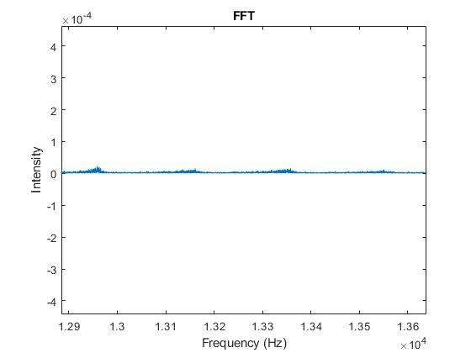
Figure 3: Kutz 100 Middle Frequency Range
The middle frequency range also exhibits some harmonics although significantly weaker. This trend also dies out around 20 kHz, which is commonly agreed upon as the limit of human hearing.
Spectrograms were also generated of the G major scale recordings, since the pitch varies with respect to time in the scale recordings. Both two dimensional and three-dimensional spectrograms were generated, each with their own drawbacks. The two-dimensional spectrogram can be seen in Figure 4. Due to the high sample rate, the spectrograms will also be need to split into three sections for analysis, as each section has different characteristics that need to be analyzed.
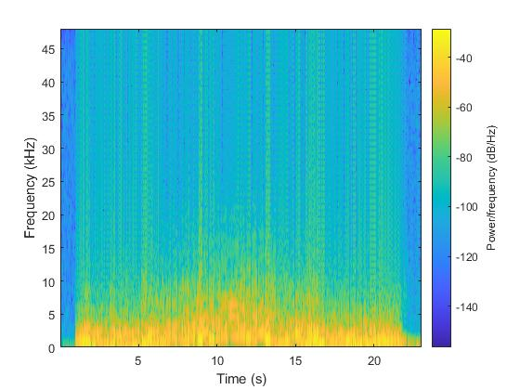
Figure 4: Kutz 100 G Scale Spectrogram
Most of the spectrogram also looks constant, since the spectrogram will also observe up to 48 kHz. The lighter color represents higher presence of harmonic. We can see steaks of harmonics going up the graph, showing that there is indeed upper harmonic behavior well beyond the human hearing range, enough to be detected by the algorithm.
Moving forward, the goal will be to extract the information contained within these higher frequency peaks. Once data processing is complete for all of the instruments, we will begin to compare instruments in the same price ranges to look for consistency and compare across price ranges to determine objective measures of differences in tone.

References
T. -A. Anderson, "Musical instrument classification utilizing a neural network," 2017 12th International Conference on Computer Science and Education (ICCSE), 2017, pp. 163-166, doi: 10.1109/ICCSE.2017.8085482.

Y. Atahan, A. Elbir, A. Enes Keskin, O. Kiraz, B. Kirval and N. Aydin, "Music Genre Classification Using Acoustic Features and Autoencoders," 2021 Innovations in Intelligent Systems and Applications Conference (ASYU), 2021, pp. 1-5, doi: 10.1109/ASYU52992.2021.9598979.

N. M R and S. Mohan B S, "Music Genre Classification using Spectrograms," 2020 International Conference on Power, Instrumentation, Control and Computing (PICC), 2020, pp. 1-5, doi: 10.1109/PICC51425.2020.9362364.

Y. Lin, W. -C. Chang and A. W. Y. Su, "Quantitative evaluation of violin solo performance," 2013 Asia-Pacific Signal and Information Processing Association Annual Summit and Conference, 2013, pp. 1-6, doi: 10.1109/APSIPA.2013.6694296.

Harmonic and Pizzicato Data Processing
In the last section, we looked at data of the Kutz #100 in lower frequencies, specifically looking at bowed open strings and bowed scales. There wasn’t a lot of high frequency action, as expected, as one hypothesis of this experiment is that high frequency content will be richer in higher quality instruments. In this section, we’ll examine the Kutz #100’s upper range by looking at the bowed open-string harmonics on each string. The effect of articulations such as pizzicato on the frequency profile will also be observed.
The FFT of the bowed open-string G harmonic can be seen below.
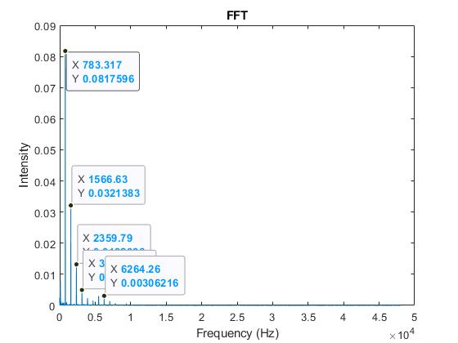
The first and strongest peak is seen at the fourth harmonic. This will be a common trend as we look at the harmonics. Following suit of the non-harmonic open strings, the intensities of the harmonics decay exponentially as frequency increases. Since this is the bowed open string harmonic, the sounding pitch is two octaves above the fundamental; our analysis shows that the strongest peak in the G harmonic on the Kutz #100 shows up in the 4th harmonic, or four octaves higher than the fundamental. This is not in line with what we hear, meaning this may be one of our quality measures for a violin—the strongest harmonic should be in line with what we hear. For this open-string harmonic, the upper frequency range is very inactive.
Next, we’ll look at the open-string E harmonic. The FFT can be seen below.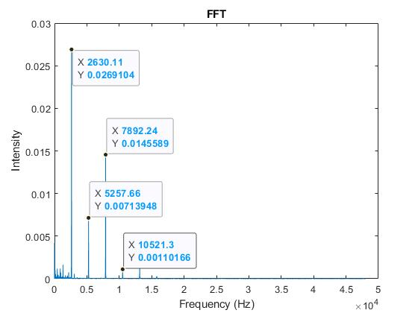
Again, the first and strongest peak is seen at the fourth harmonic. Note that the peak intensity for the first peak is 4 times weaker than the peak intensity for the first peak on the G harmonic. The harmonics after the first peak also generally follow an exponential decay—the only difference is that this time, there is activity in the super-sonic range. Any frequencies greater than 20 kHz are classified as super-sonic, as they are beyond what is widely considered the limit of the human hearing range. The FFT of the super-sonic range for this recording can be seen below.
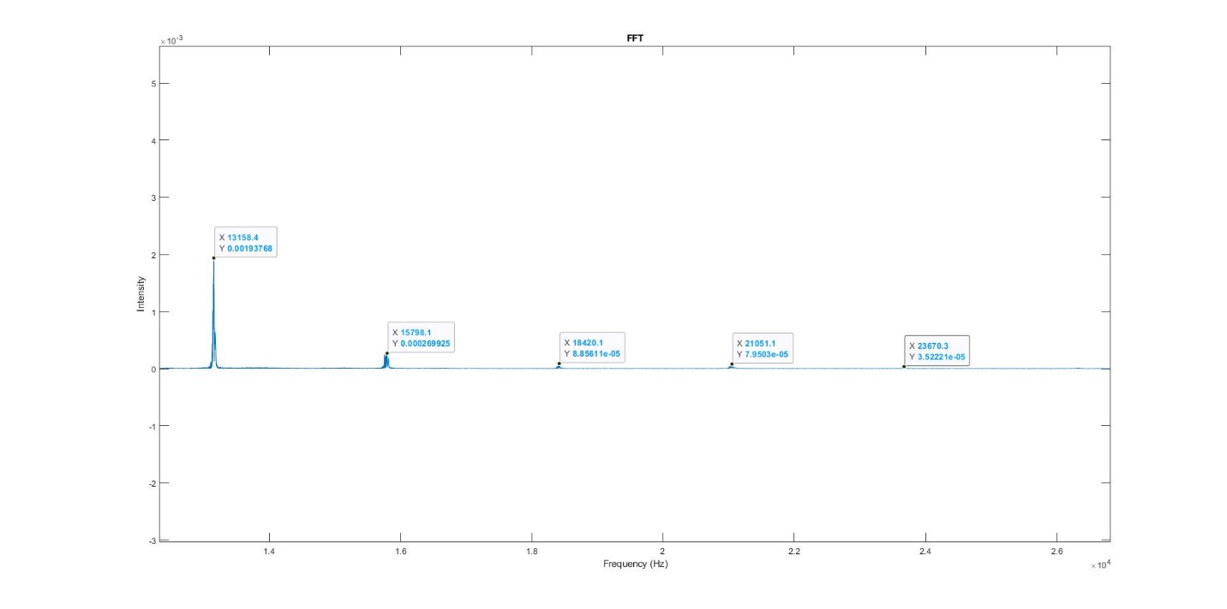
This is very promising, as it confirms that there are super-sonic frequencies that are detectable, even on cheap violins. This means that we can compare the super-sonic range on cheap violins against more expensive instruments and see if any patterns can be detected. While the peaks have a very small magnitude, they are still detectable relative to the rest of the data.
Next, we looked at the pizzicato data. The FFT of the open G pizzicato can be seen below.
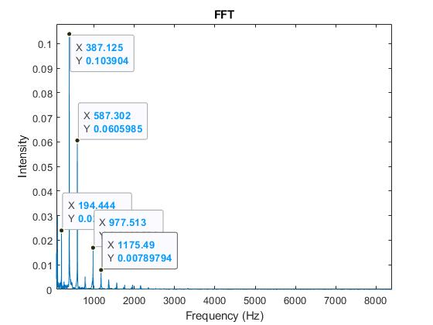
For this recording, the strongest peak occurs at the second harmonic, although the fundamental is significantly more present than in the past, albeit still overshadowed by the upper harmonics. The peak intensity is also 25% stronger than the peak intensity in the bowed open string and bowed harmonic open string. This makes sense, as the intensity of the peak is a measure of how much energy that frequency carries—since a pizzicato has a sharp attack, there is a large concentration of energy in the recording, yielding a significantly higher peak in this section as compared to others.
The main point of looking at the open-string harmonic recordings was to determine if there is any high frequency action, which there is in places that we would expect it to be. The purpose of examining the pizzicato recordings was to make sense of the intensities, and ensure that our data processing methods are consistent with what we would expect.

Comparing Data Among Low Range Instruments
In the last section, we looked at more in-depth data processing, primarily looking at the higher range of the Kutz 100 violin by looking at its E harmonic spectrum. We determined that even the cheapest instruments have a relatively active super-sonic range, and that it is present and detectable relative to other frequencies in the spectrum.
In this section, we will begin to compare data between same and different price ranges. The Kutz instruments will be compared against each other to determine any trends that may appear in cheaper instruments, and the Cheng and Kono will be compared against each other to determine any trends that may be present in more expensive instruments. At the end, we’ll compare one of the Kutz instruments against the Kono, which are both at extreme ends of our price ranges.
For this section, we’ll be looking at harmonic intensity plots that are overlaid on top of each other. The first plot we’ll look at is the Kutz 100 #1 Open G recording vs. the Kutz 100 #2 Open G recording. The lower third of the harmonic intensity plot for these two recordings can be seen below.

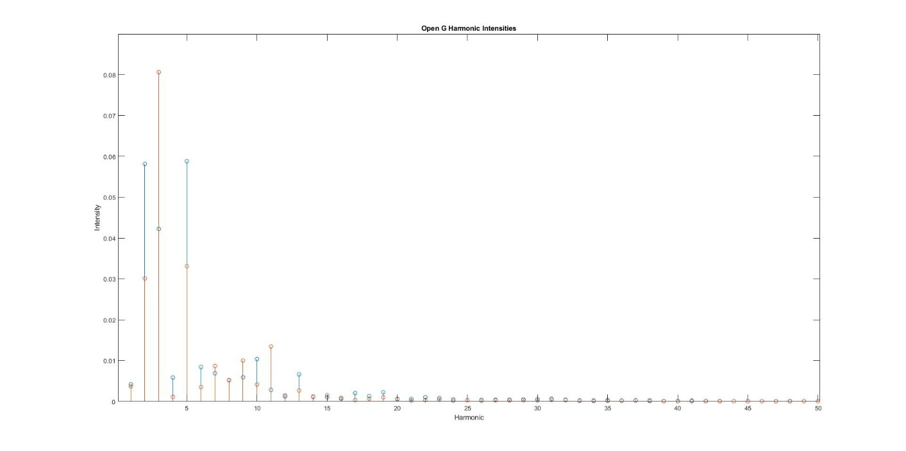
Figure 1: Kutz 100 Open G Spectrum
The orange stems represent the second Kutz 100 recording, and blue stems represent the first Kutz 100 recording. Upon initial inspection, the peak harmonic is different between the two recordings—the peak harmonic for the first Kutz is tied between the 2nd and 5th harmonics, while the second Kutz clearly has its peak at the 3rd harmonic. The intensity of the peaks is also off by about 25%--the second Kutz’s peak is 25% stronger than the first. Other than that, the data seems to be consistent between the two instruments. As we look at higher harmonics, the patterns tend to converge, as expected. Since these two models are the same, we would hope that there isn’t a lot of difference. Since we’re looking at the G string, there is no point in looking at the super-sonic range, since the intensities in this range are not relatively large.
Next, we’ll look at the Open E string recordings for both instruments. The lower third of the harmonics can be seen in Figure 2.

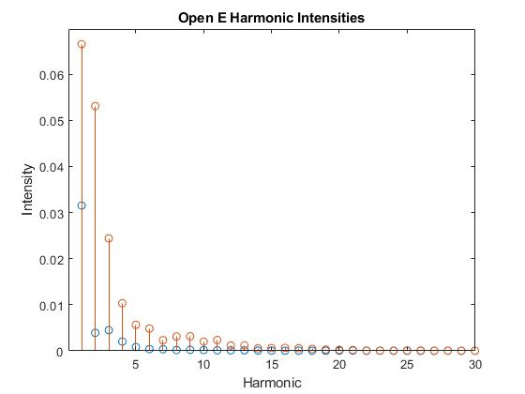
Figure 2: Kutz 100 Open E Spectrum
For the open E, the two instruments follow a much more similar trend—the peaks in both instruments occur at the first harmonics, followed by a similar exponential decay until the trends converge. Note that the second instruments intensities are always greater than the first instrument. This may be due to the fact that the second instrument’s recording is both shorter and louder, leading to a more concentrated spectrum. The fundamental for this instrument is 659 Hz, meaning that the 30th harmonic would put us near the super-sonic range. It is evident that the 30th harmonic in this case is not relatively large, so the upper frequencies can also be neglected here.
Next, we’ll look at the Open G Harmonic recordings for both of the instruments. We expect the peak for all of these to be two octaves (or two harmonics) higher than the fundamental, as the open-string harmonic on violins produces a pitch that is two octaves higher than the fundamental pitch on the string. These plots can be seen in Figure 3.

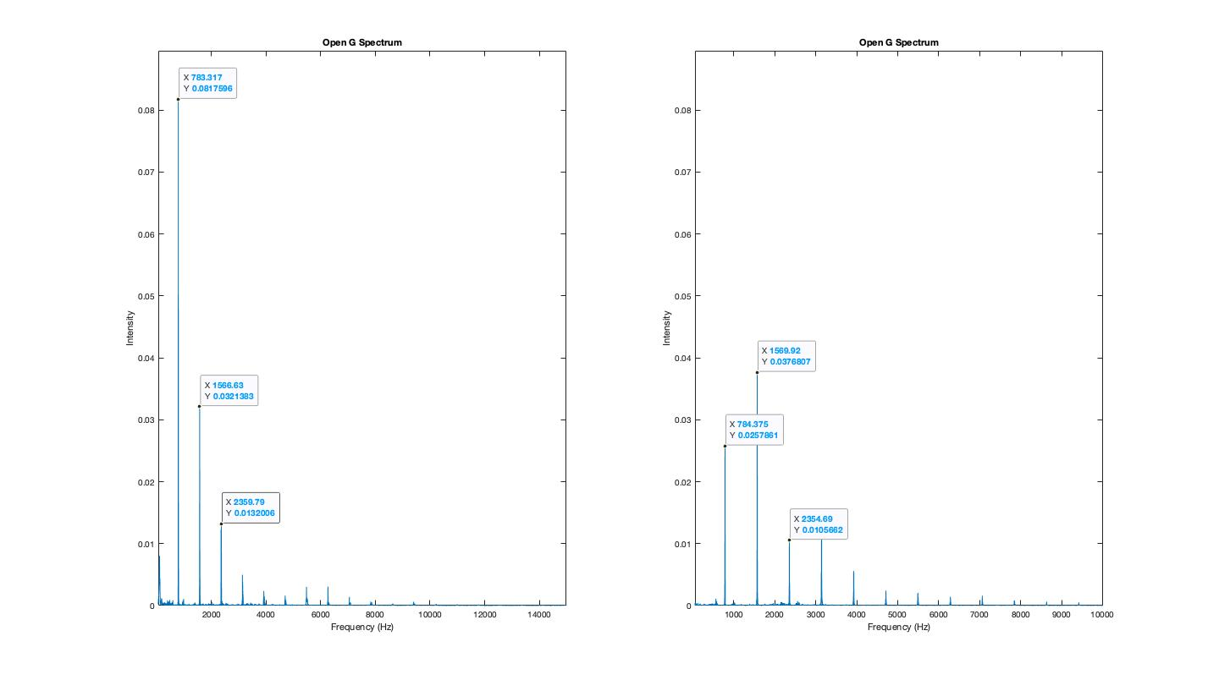
Figure 3: Open G Harmonic Spectra
Looking at the harmonic spectra gives us some more consistency among the data—note that while the first harmonic intensities are very different, the second and third harmonics have almost the exact same intensity between the two instruments. This makes sense and is in line with what we would expect—the first harmonic’s wide discrepancy can be attributed to volume and duration of the recording. The upper frequency range for this instrument also follows the same general trend. Since we’re looking at the G string, the upper spectra can be neglected, as peaks are not relatively strong here.
Next, we’ll look at the Open E Harmonic for both recordings. For this sample, we need to look at the lower and upper frequency range, as we know from the last section that this contains relatively strong super-sonic frequencies. These plots can be seen in Figures 4 and 5.

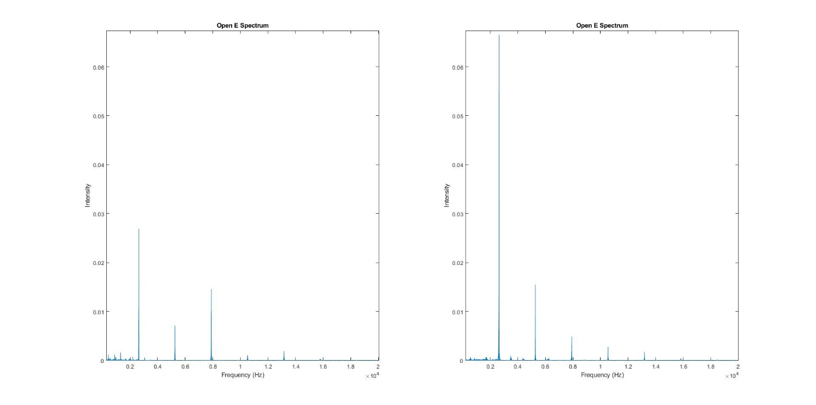
Figure 4: Open E Harmonic Lower Spectrum
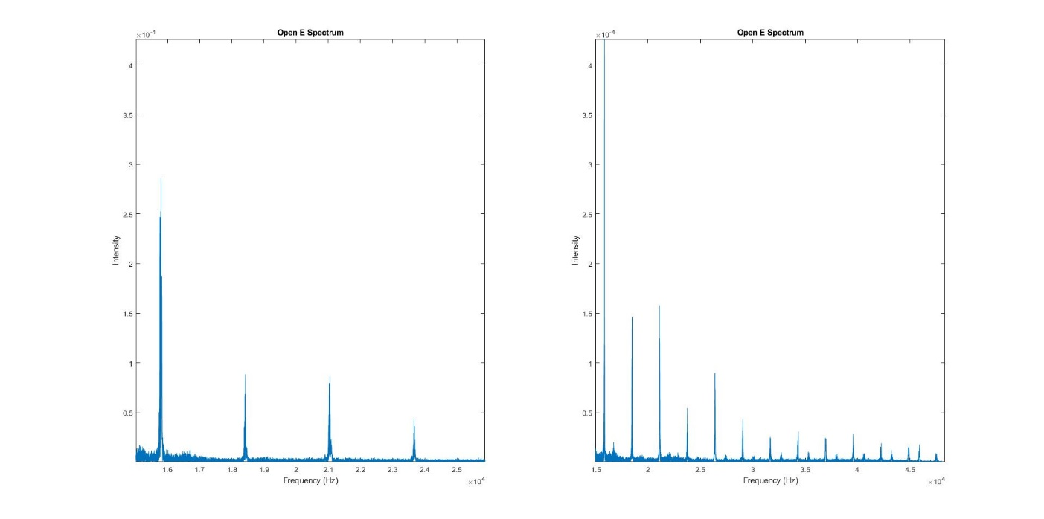
Figure 5: Open E Harmonic Upper Spectrum

For this recording, we see that the second instrument has a more active spectrum throughout the upper and lower ranges. This may be because of inconsistencies or errors in recording, as the spectra of the two instruments has been relatively consistent thus far. There is little to no consistency across the two instruments in this case, which may be cause for concern—this much error in the recording process is unlikely, so it’s possible that the two instruments may not be exact replicas.
Regardless, we find that the upper spectrum is more active than any of the other strings, as we expected. The first instrument has relative peaks in the super-sonic range that last until about 24 kHz, while the second instrument has a much more active super-sonic range. The second instrument has a super-sonic range that is relatively significant into around 40 kHz. It should be noted that while there are peaks in this area, they aren’t necessarily harmonics. We can determine this from the fact that we would expect the peaks to be evenly spaced, as harmonics occur on even intervals. The spacing is more inconsistent in frequencies above 30 kHz.

Comparing Data Among High Range Instruments
At this point, we’ve compared the frequency spectrum for many different recordings and ranges for low-range instruments. We found that there was a lot of variance in the data between identical models, specifically for the G string on the violin. This tracks with anecdotal claims, as one of the main distinguishing features between a cheap and quality violin is a rich tone on the G string.
Looking at the higher frequencies in our low-range instruments confirmed the hypothesis that there relatively detectable super-sonic activity in the higher frequency ranges. This was prevalent in both of the instruments on the open E harmonic recording, although the intensity of one of the instruments was significantly different compared to the other—this may be due to discrepancies in recording methodology and construction of the instrument.
In this section, we will perform a similar analysis for the higher price range instruments. This includes the Kono and John Cheng recordings. The same recordings that were covered in the previous section will be covered here as well, with the same general structure of comparison, to maintain consistency between our analyses.
We will first look at the Open G string recordings of the Kono and John Cheng. We will only look at the lower spectrum of this recording, as there is no relatively detectable super-sonic activity in the G string recordings. The two instruments’ lower spectrum can be seen overlaid in Figure 1.

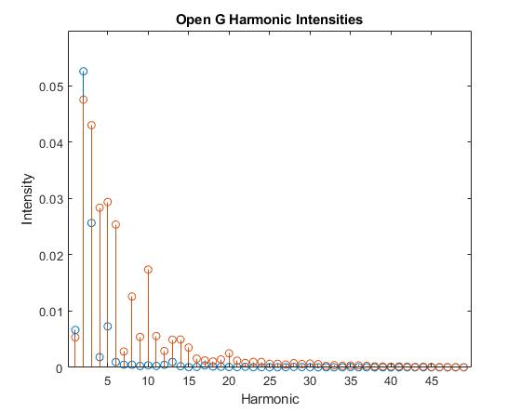
Figure 1: Open G Harmonic Intensities
The plot above shows the Kono’s spectrum plotted in blue and the Cheng’s spectrum plotted in orange. As expected, the two spectrums for the two instruments is wildly different. This is to be expected, as we noticed in the previous comparison section that the G string’s data was very different, even across identical models. Based on this, it makes sense that the data shows no correlation between instruments that are different.
It should be noted that the John Cheng, which is the cheaper of the two instruments, has two peaks of nearly equal intensity in the lower harmonics. The Kono has one distinguished peak at the second harmonic, followed by a sharp exponential decay leading into the higher harmonics. It would take a larger sample size to come to any solid conclusions, but a sharp exponential decay in the G string’s spectrum may be linked to richness in sound.
Next, we’ll look at the open A string’s spectrum for both instruments, examining only the lower frequencies. These plots can be seen in Figure 2.

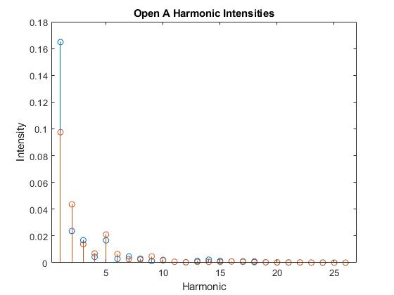
Figure 2: Open A Harmonic Intensities
Again, the Kono is plotted in blue, and the Cheng is plotted in orange. For this recording, we find that other than the first harmonic, the two recordings follow generally the same trend, with small variations that can be attributed to error in the recording process. The difference in the first peak, however, likely cannot be attributed to differences in recording methodology, as there is a difference of about 60% between the two peaks. Other than that, the instruments follow almost exactly the same trend. This is to be expected as, anecdotally, the A string is one of the hardest to distinguish between higher quality instruments.
Next, we’ll begin to look at open-string harmonic recordings. Like in the last section, we will look at the harmonic spectrum as opposed to a harmonic intensity plot, as these recordings are more complex from a data analysis point of view. The harmonic spectrum for the open G harmonic recording for both instruments can be seen in Figure 3.

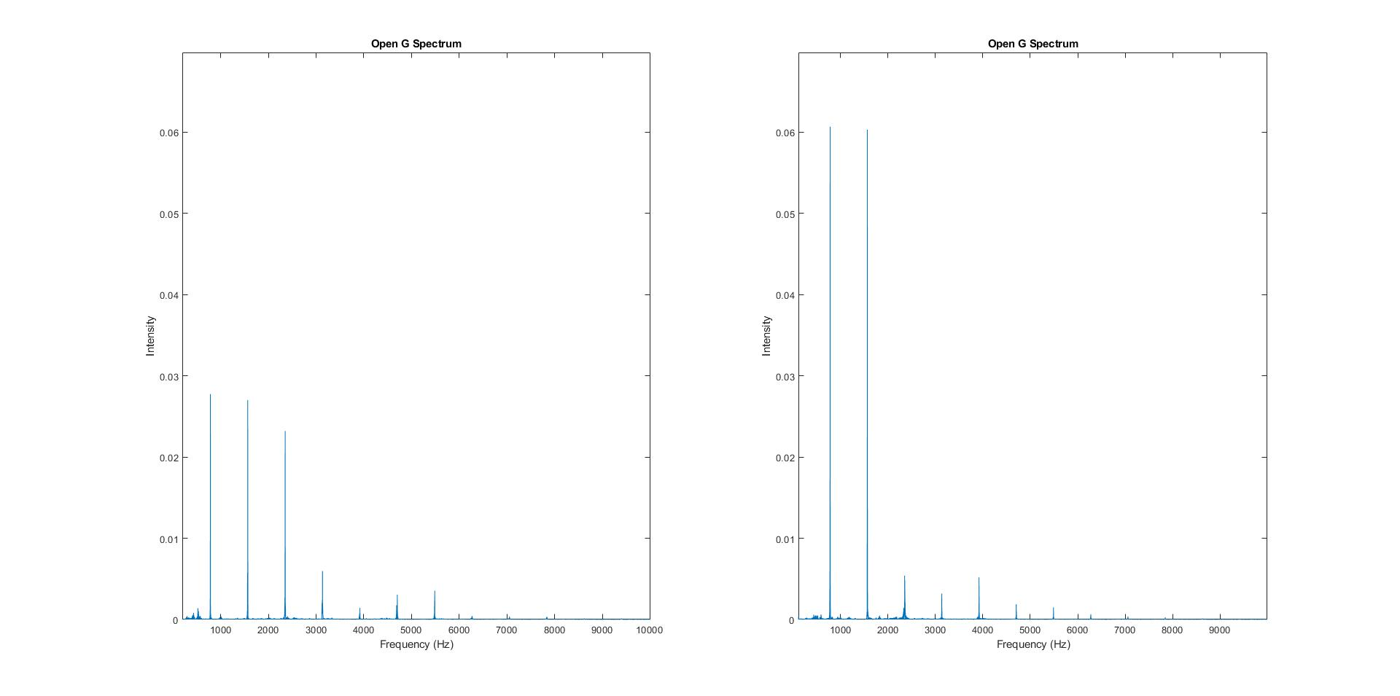
Figure 3: Open G Harmonic Spectrum
With the Kono on the left and Cheng on the right, we see a similar trend in the harmonic spectrum compared to the open G harmonic intensity plots we saw before. The Cheng has much stronger peaks in the first couple harmonics and quickly decays. The Kono follows a similar decay pattern, but with much weaker initial peaks. This can’t be attributed to recording error, as the peaks in the Cheng are more than twice as strong as the ones in the Kono. This may imply that higher quality instruments have their spectral power in the open-string harmonics more distributed than lower quality instruments.
Both instruments have a frequency band of about 6 kHz, with no action in the super-sonic range—this is to be expected, as the fundamental in these recordings is less than 1 kHz. To see any super-sonic behavior, we would need the 20th harmonic to have relative intensity.
Lastly, we’ll look at the open A harmonic recordings. The spectrum for the two instruments can be seen in Figure 4.

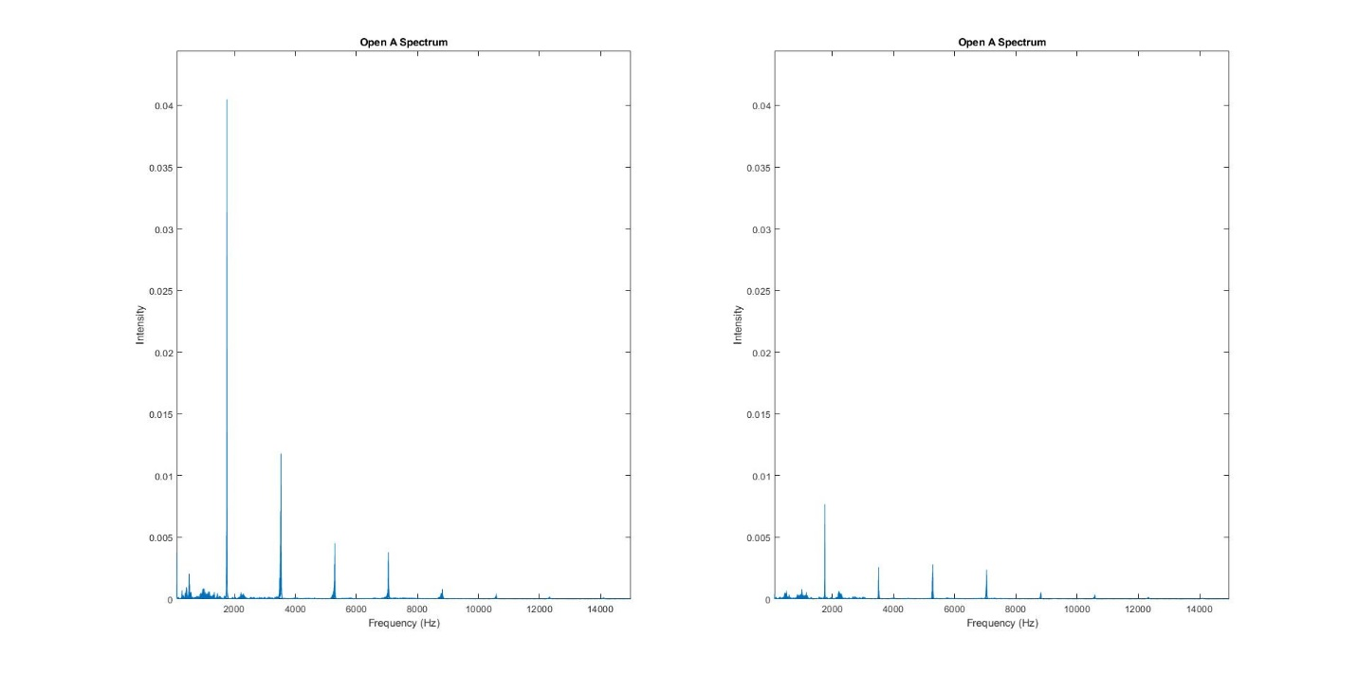
Figure 4: Open A Harmonic Spectrum
Here, we also see trends from the open string recordings make their way into the harmonic recordings. The Kono’s fundamental here is four times stronger than the fundamental in the Cheng. Other than that discrepancy, the two generally follow the same trend. This is a very similar structure to the open string recordings. This is both good and bad, as it tells us that our data and conclusions are consistent, but also tells us that the open A harmonics may not be useful for getting any new information. These recordings have a bandwidth of about 10 kHz, with activity into the 12 kHz range.

High and Low Range Comparison
In previous sections, we look at the high range and low range instruments isolated and compared their recordings against each other. We did this primarily to determine trends, consistencies, and inconsistencies in the data. In our comparisons, we found that some of our open E string harmonic recordings exhibited super-sonic behavior while some did not. We also saw that the open G string recordings varied widely as expected, since the open G string is anecdotally considered to be a good “tell” of a quality violin.
In this section, our goal is to compare instruments across varying price ranges to determine what objective measures from the data can be used to determine if one instrument is of higher quality than another. We’ll be looking at the same instruments and same recordings from previous section, but this time, we’ll be comparing high price instruments against low price instruments. Specifically, we’ll be looking at the Kono and one of the Kutz #100 violins.
First, we’ll look at the open G string recordings for these two instruments. The harmonic intensity plots for these two recordings can be seen in Figure 1.

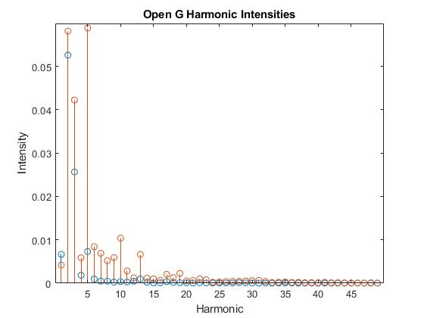
Figure 1: Open G Harmonic Intensities
The plot of the harmonic intensities of the open G recording for the Kono and Kutz #100 can be seen above, with the Kono in blue and the Kutz in orange. The peak for the Kono occurs at the second harmonic and is distinct, followed by an exponential decay in the upper harmonics. The Kutz, however, has its maximum harmonic intensity at the fifth harmonic. Not only is its peak later, but the Kutz also has a similar but slightly weaker peak in the second harmonic. Like the Kono, it follows an exponential decay, but the decay on the Kutz’s spectrum is much noisier. From this, we can say that higher quality instruments may have a cleaner and more well-defined harmonic spectrum on the G string, as opposed to lower quality instruments having a much noisier lower spectrum.
Next, we’ll look at the open E string recording for both instruments. The harmonic intensity plot for these recordings can be seen in Figure 2.

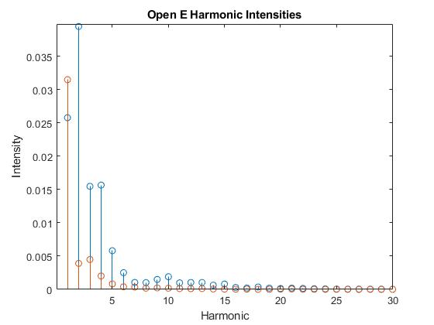
Figure 2: Open E Harmonic Intensities
The plot for the harmonic intensities for the E string can be seen above, again with the Kono in blue and the Kutz in orange. The peak harmonic for the Kono occurs at the second harmonic, while the peak harmonic for the Kutz occurs at the first harmonic. After the peaks, both instruments follow an exponential decay; the decay on the Kono is slightly noisier than the decay on the Kutz. The Kono also consistently has stronger harmonic intensities than the Kutz, normally by about a factor of 3. From this, we can take away in general that for the E string, higher quality instruments will have stronger upper harmonics, while lower quality instruments’ upper harmonics will die out faster. It should be noted that both recordings had a completely inactive ultrasonic spectrum. This may be attributed to variations in the recording process.
Next, we’ll look at the open G harmonic recordings. The frequency spectrum for these recordings can be seen in Figure 3.

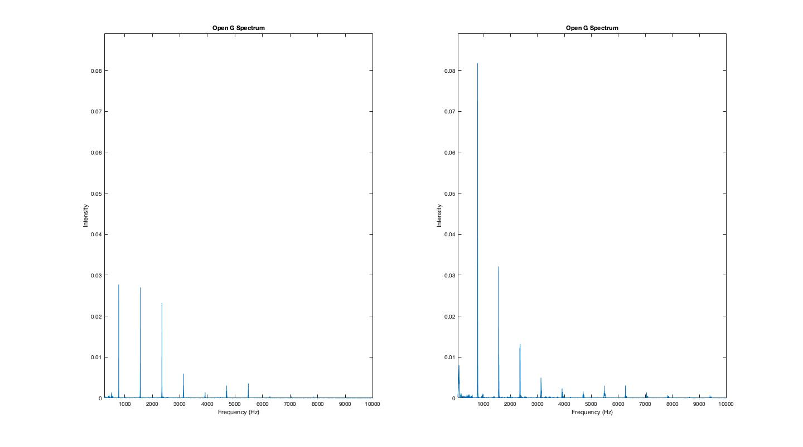
Figure 3: Open G Harmonic Frequency Spectrum
The Kono’s frequency spectrum for the open G harmonic can be seen to the left, and the Kutz’s frequency spectrum can be seen to the right. The Kutz’s frequency spectrum follows the noisiness of the open G, while the Kono’s frequency spectrum has less detectable upper harmonics. This data is not very consistent and is lacking with what our expectations would be. This may be due to inconsistencies while recording or statistical variations because of how small our sample size is. Regardless, other than the consistent nosiness of the Kutz, not much can be taken away from these recordings.
Lastly, we’ll look at the open E harmonic frequency spectrums. These can be seen for both instruments in Figure 4.

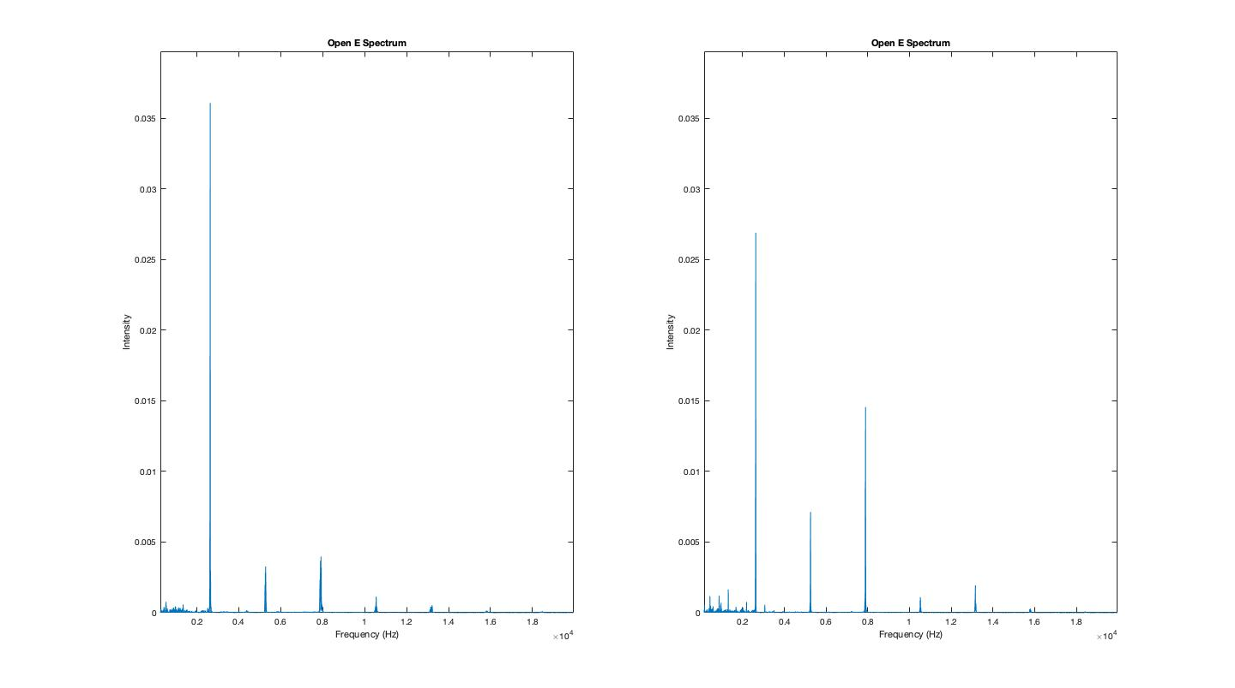
Figure 4: Open E Harmonic Frequency Spectrum
Again, the Kono’s frequency spectrum for the open E harmonic recording is plotted on the left and the Kutz is plotted on the right. The noisy behavior of the Kutz persists in this recording, and the clear behavior of the Kono also presents itself. There is a distinct peak on the Kono with the upper harmonics decaying rapidly, while the Kutz’s upper harmonics do not decay as rapidly. Not much can be said from these recordings either due to inconsistency and the small sample size. Only general claims about the data can be made.

